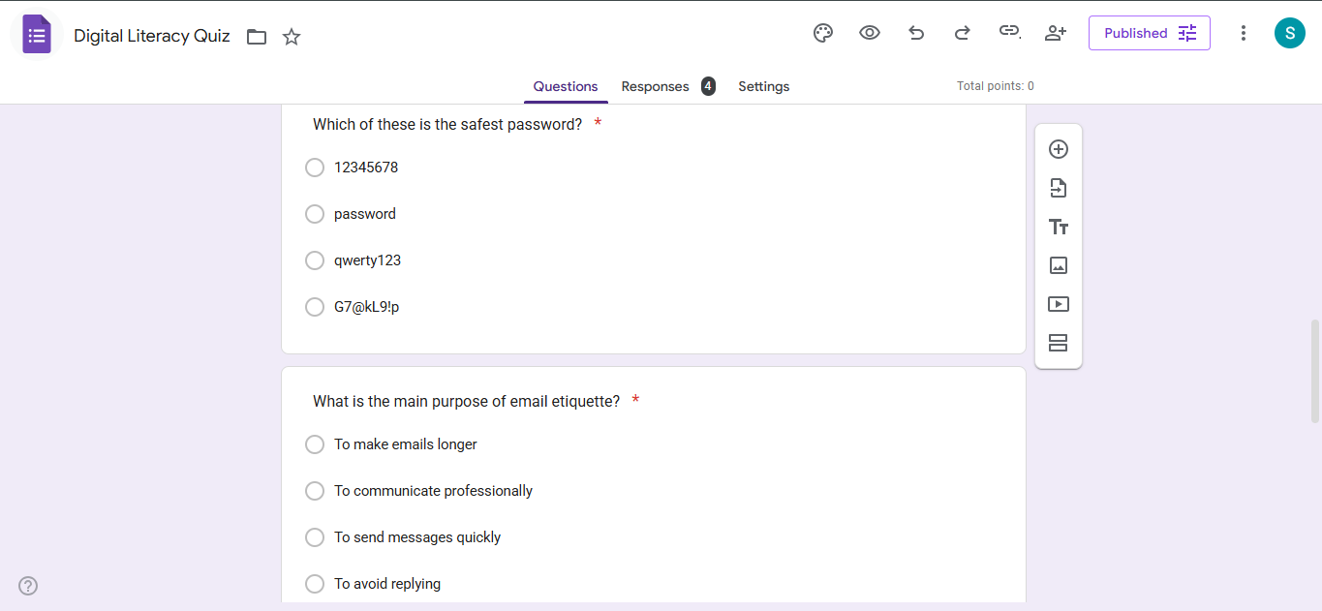
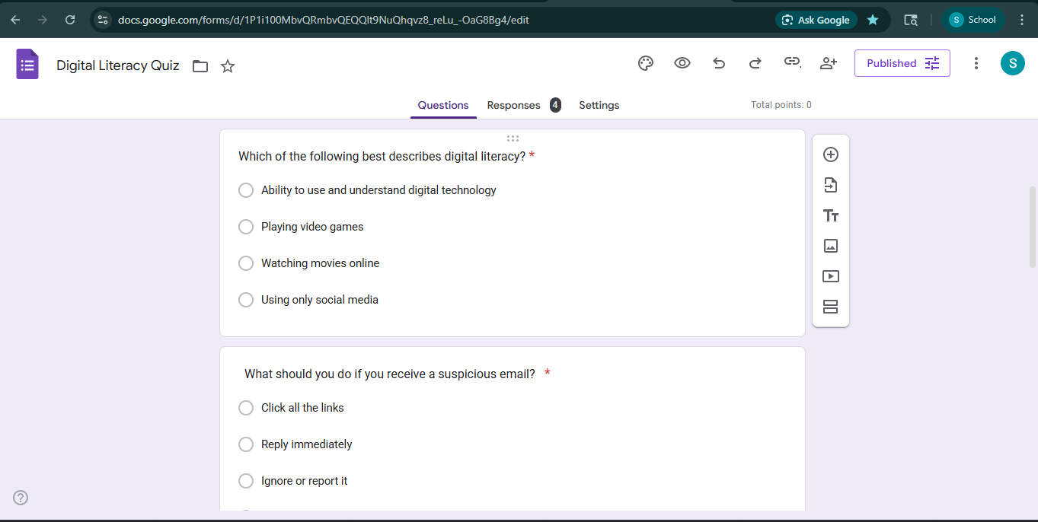
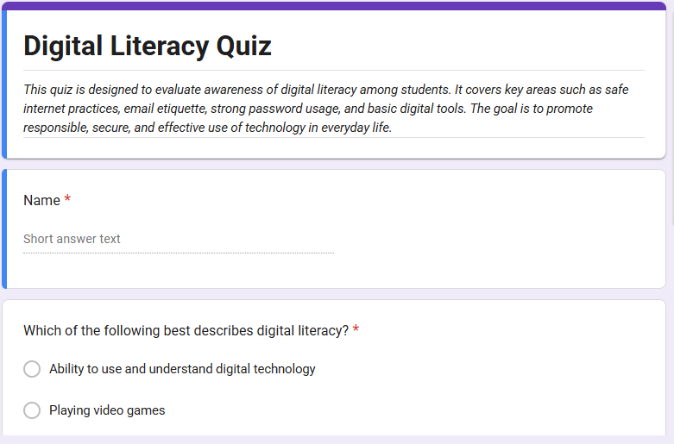
Google form “Digital literacy quiz”:
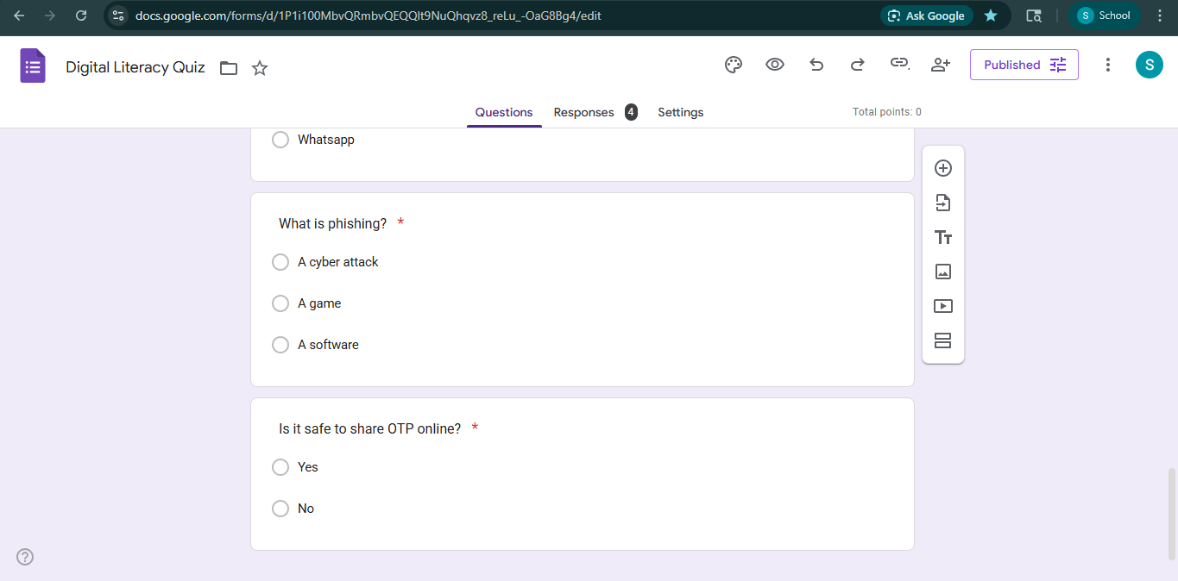
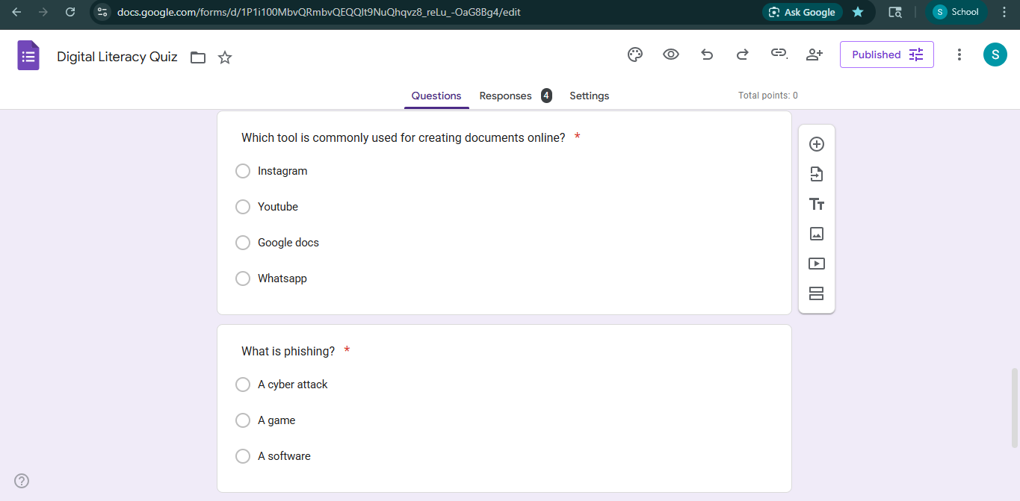


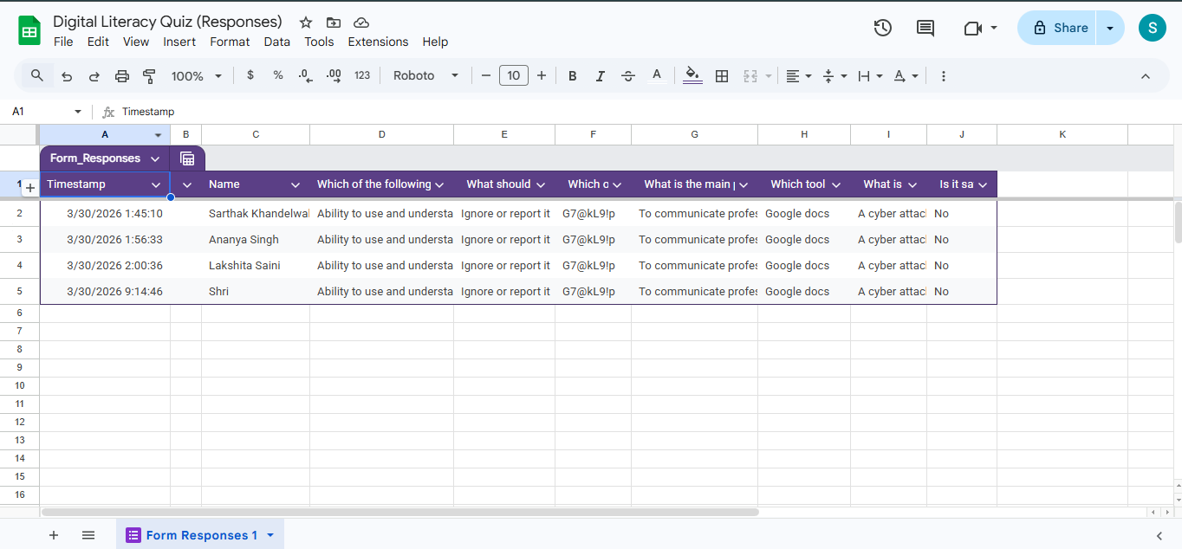
Google form responses:

Google form link:
https://docs.google.com/forms/d/e/1FAIpQLSe7PhWB-JGFZNQEkso14FdGuMByKg-bXuRIEzJYT2cUBWfbLA/viewform?usp=header

